📜 Complete List of Gupta Dynasty Rulers (गुप्त वंश के सभी शासक)
🟢 Early Gupta Rulers:
- Sri Gupta
- Ghatotkacha
🟡 Imperial (Main) Gupta Rulers:
- Chandragupta I
- Samudragupta
- Ramagupta (विवादित शासक)
- Chandragupta II
- Kumaragupta I
- Skandagupta
🔵 Later Gupta Rulers:
- Purugupta
- Kumaragupta II
- Narasimhagupta
- Budhagupta
- Vainyagupta
- Bhanugupta
- Vishnugupta

📌 UPSC Important Points:
- संस्थापक → Sri Gupta
- सबसे महान शासक → Samudragupta
- विक्रमादित्य → Chandragupta II
- अंतिम शासक → Vishnugupta
अगर चाहो तो मैं इसका timeline chart या mnemonic trick भी बना दूँ जिससे याद करना आसान हो जाएगा 👍

Gupta Period ][]

Gutpa kaaal me art science and literature inka bahut he vikaaas hua hai gutpa period ko bharat ka swarn yug bhe kahah jata hai
Gupta kaal ko swarn yug uske sainya ya adminstation ke wjah se nahi kaaha jata gupta kaal ko swarn yug use literature, klaa artand prodyogekee technology ke wajah se kahah jata ahi
It is called classical age of india because it witnessed emensee development in the field of art, architecht, science , technology, and literature

To wo hame bhaut he ache se padna hoga wahah se kaun kaun se mahahn vidwan hue unke books kis tarah ke scientific discovery is time epr dekhne ko milte hia to bahut sare sawala in subject se puche jate hai

Ek hamne Maurya samrajay ko padta tha jisme mauryan ne kitne pade paimane per Maurya samrajya ko fiala kar rakah tha
This is called last empire of ancient india
Hum bharat ke anteem samrajya ke bare mepaddh rahe hai wo hai gutpa samrajya
Uttar bharat ke bhaut bade chetro me inhone shahsan kyia hai
Jb uttar me gupta shashan kar rahe the to Dakshin bharat me vaktaka shasan kar rahe the and west me shaka dekhne ko milenge jinko paschimi chatrpa blte hai

Gutpa shako ko hara denge uske baad wo area bhe gupta ke sahshan kaal me aa jayega
Vkataka se saht gutpa ke bahut he ache realtion the

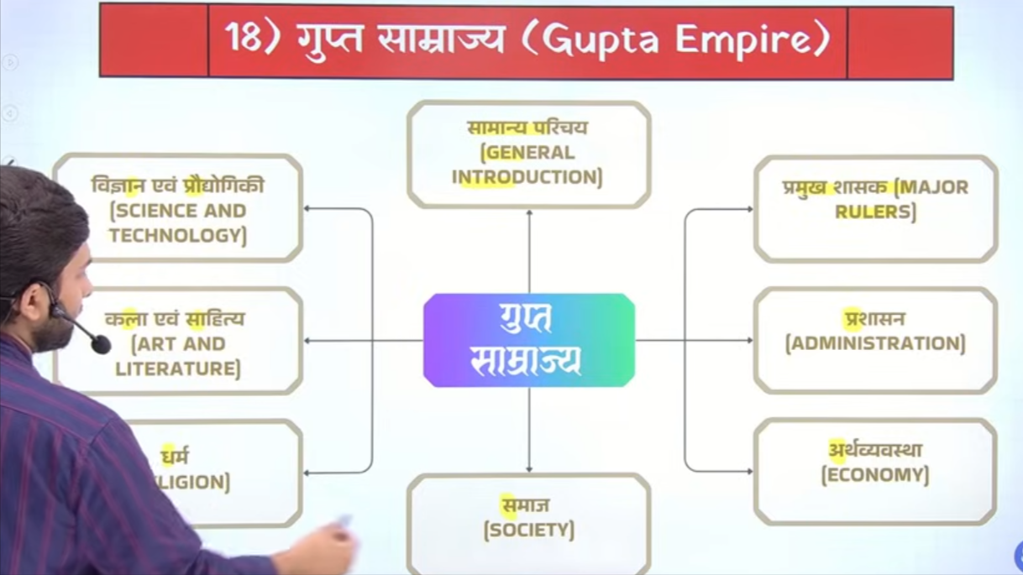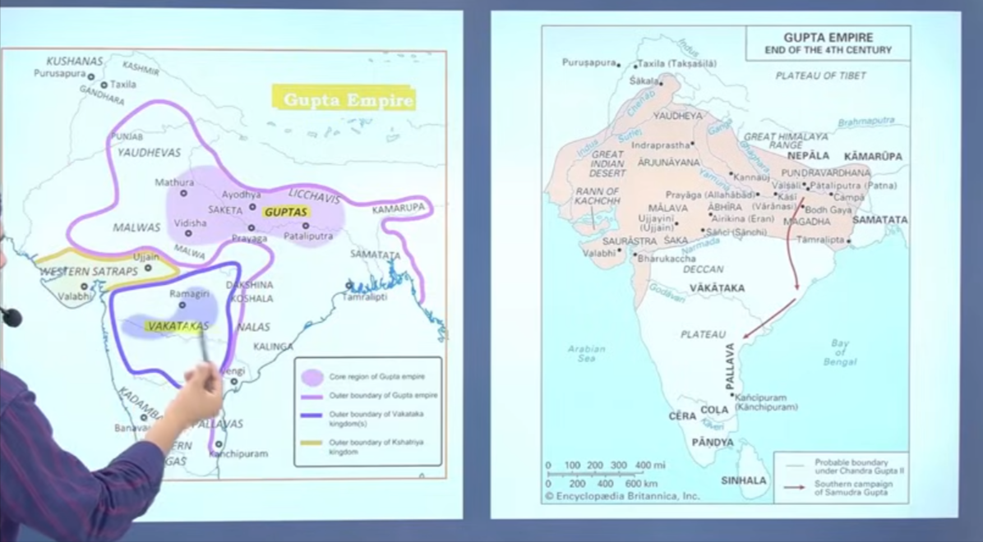

Gutpa time per iod is 275 CE- 550Ad
Lekin kae book me likha rahah tha 319-500 uska kaaran hai kuki kae book shrigupta ko vastvaeek sanadhtapak nahi mante hai
Balke actual founder chandruapta first ko mante hai

It is called golden age of india it witnessed great development of art lirterature , science and technology

Gupta kusahnaio ke samnt the mukya roop se inke utpate kausambi wale Chetra me raheh ahi

Gutpa samrajya ka china symbol tha garun

Rome me jo samradhii ka kaal rahah usko Periclean age bhe kahah jata hia isley
Gutpa ke time ko bhe bharat ak Periclean yug kaha jata hai
To j brome se bharat ke tulna keg ae tb

‘
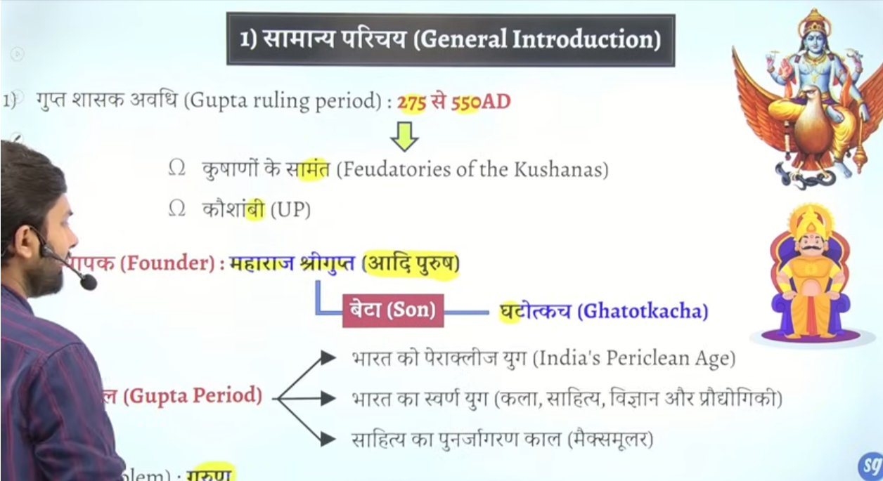

Chandragutpa first ko real founder vastveek sansthapak manaa jataahi
Samdurdagutpa jinko bharat ka nepolean kaha jayega
Sabse adhik samrajya vistar samudragupta ke sahsan kaaal me hoga
Chandrgupta second jinhone vikramadyita ke upade dharna ke the aur inke darbaar me nine gems the naur ratna the
Kumargupta jo ke Nalanda viswavidyala se jude hue hia
Skandgupta jinke time per bharat me first time hun akraman hua
Last is visnugupta

Gupta kaaal ka adipurush kise kahah jata hai to answer is shree gutpa ko
Gutpa vansh ke sansthapak ka nam shri gupta
Leking gupta vansha ka vastveek sasthapak chandragutpa first

Bharat ka periplize , swanr yug ya fir saheitya ka punrajagarna kaal kise kahh jata hai to answer is gupt aperiod
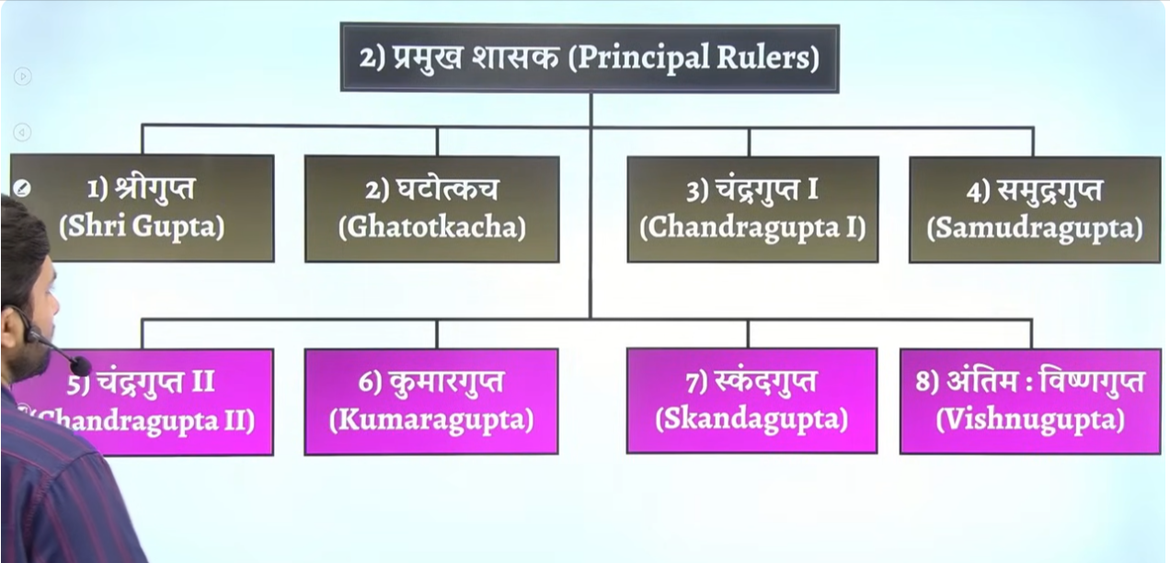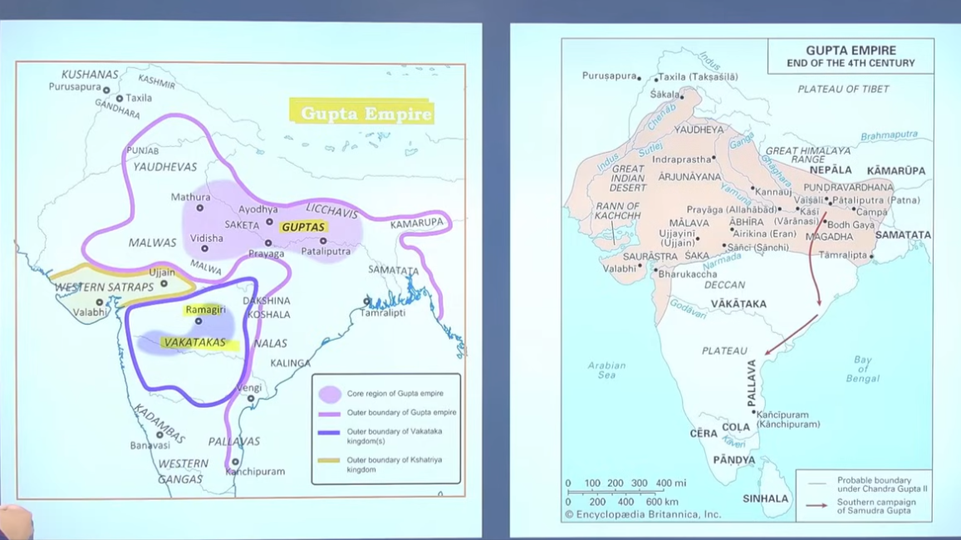

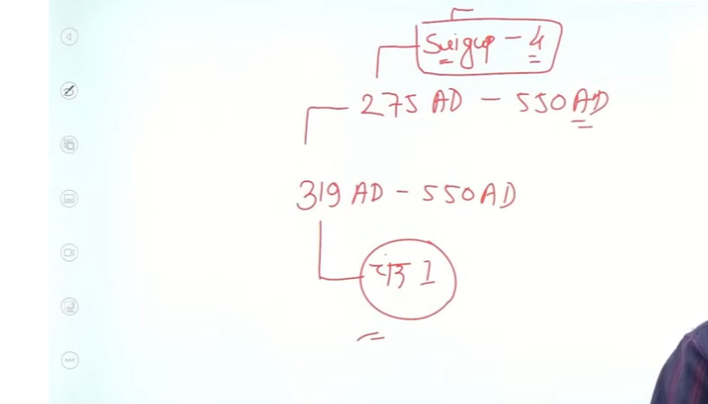

Kae jagah per inke time period 319-550 ad
Aur kae jagha per 275-550 Ad hai
Kuki 275- me shrigupta ka shashan tha aur uske baad gatotkach ka shaahn yaay
Inko vastveek sansthpak nahi mana jata jbke shregutpa ke paas mahraj ke upade the
319- whne chandrautpa first became the ruler he was called the acutal founder of the guta dynasty to unhe kahah gayay ke ye gutpa vansh ke vastveek sansthapak hai
Shreegutpa ne maharaj title lyia tha
But chandrutpaf first is the first ruler of gupta dynwast who take the title of mahrajadhiraj
Question us gutpa shahsk ka naambatyai jise sabse pahle baar maharjadeiraj ke upadi dharan ke the

Lichvi ke sath inke sambhand ache nahi the but kahe na kahe vivah niti k dwara lichiv wala Chetra bhe inke under me aa gyaya tha

To vivah ke nikti ko bhaut ache se implet kyai tha wo tha first time bimbisar
Inhone ek Samvat suuru kyia tha gupta Samvat jo ke kae book me 319 Ce ya 320 Ce hai

Jis saal inka cornotion hua us saal he inhone ke new Samvat sstart kyai gupta Samvat
First two Samvat is viram Samvat , shak Samvat third is gutpa Samvat

Abhe jo samay chal rahah isme agar 57 jod de to Vikram Samvat mil jayega

Aur abhe jo samdsy chal rahah usme se 78 – minus kar do to sahak Samvat mil jayega
Aur abhe o samdya hais usme se 319 minus kar do to gupta Samvat mil jayga

Calendar 0 se shrua hua sahk samvat 78 me ayay gutpa Samvat 319 me aya liend Vikram Samvat purana hai wo 57BCe ka hai

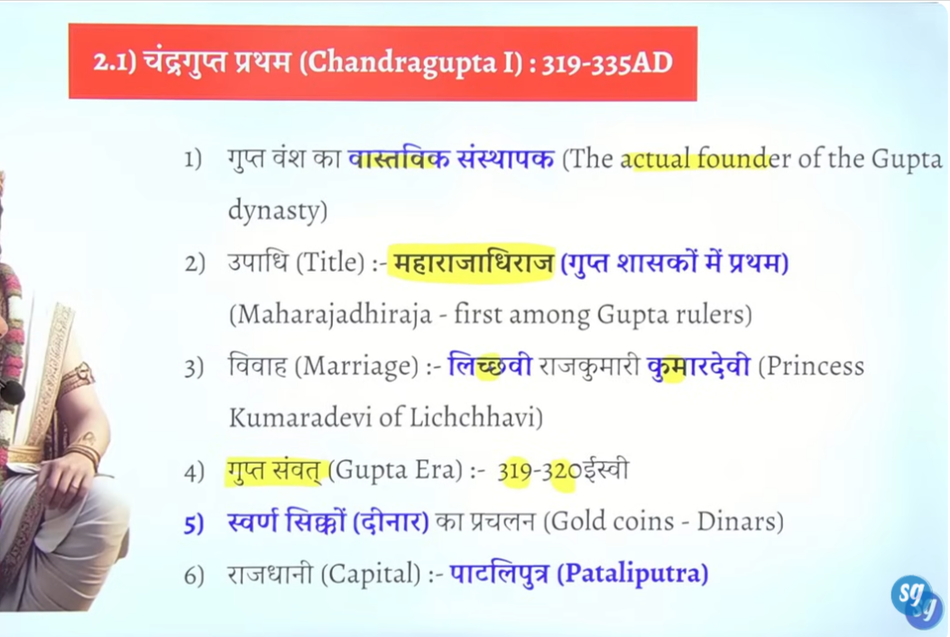

Maximum number of gold coin issued during gupta period

2
Date ko lekar ke thode confusiton books me dekhne ko milege
Samdurgtua ke regime me gupta dynasty ka sbase Jayda expansion hu yahe karan hai vinsent aurthor smith ne the early hisotyr of india jo unke book ka naam hai usme samduragupta ko bharat ka nepolean kahah hai
Ye guta vansh ka sabse shaktishale shask hua h
Ye gutpa dynasty ka sabse powerful ruler tha

Samduragutpa ne kuch sone ke sikke jare kyia gayay jisme wo vina bajate hue coins per ankeeet kyia gaye hai smduraptu ko inscribe kyai gyaya hai that he is playing veena

Nepolian isley kaha kuki isne aryavarat ke means north ke 9 rulers ko south th ke 12 18 atveek rajyon ko aur seemant rajyon ko harya aur bahtu bade paimane per gupta samrajya ka vistar kyai
Gupta empire ka maximum expansion iske time per he hua hai

9 state uttar ke complete merge kyia vilya kyia tha in 9 rjayon ka
And jo south ke 12 rjaya the unko jetne ke baad usne whaha ke rjaajon se bola ke rule apap he karo bas apap tax dete jana apne state ka usne inka vilya nahi kya
Kuki parevhan va Sanskrit ke samsya the jise south me vilya nahi kay
To 12 rajon ko jitne ke baad unse ek nischit tax lene ke baad unko unka rajya wapaas kar dyia tha

Yahe karna hai ikso bharat ka neopliean kaha gya

Aur ey sare Kahane hume Allahabad ke Prayag prasthi se milte hai
Pryaaga prashasti Ahsoka ka ek iistamb pillar insctipion hai
Ye muul roop se ashok ne kausambi me banwaya tha Up me
Baad me akabar ikso Allahbad lekar ayay tha pryagraaj lekar ayay tha

Bad me isem samdubgtaput ne apnsa inscittpon likwaay aur
Uske baad jahankgir ne bhe apna inscriton likhway tha isme

Samduragpa ke kavi aur sandhivikrak harishen ne
Champu sahile ka proyg karte hue isme sankrit me likha
Ot question bante ahi samdugtuap ne jo vijya abhiyaan kyia hai uske jankari hume kahah se milte hai
To samdurgautpa ke sabhe abhyiono ke jankari hume pryagprashit se milte hai
Prayrpashi ko muul roop

The Allahabad Pillar Inscription (Prayag Prashasti) of Samudragupta consists of 33 lines of Sanskrit text, inscribed in the Brahmi script.

The Prayag Prashasti, composed by court poet Harishena on the Allahabad Pillar, primarily serves as a glowing eulogy focusing on Samudragupta’s military triumphs rather than a detailed account of his struggle for the throne. While it establishes his legitimacy as the chosen successor of Chandragupta I, it concentrates on his conquests of Aryavarta, Dakshinapatha, and border kingdoms.

Pryagprashiti me samudragutpa ke prashansa keg ae hai

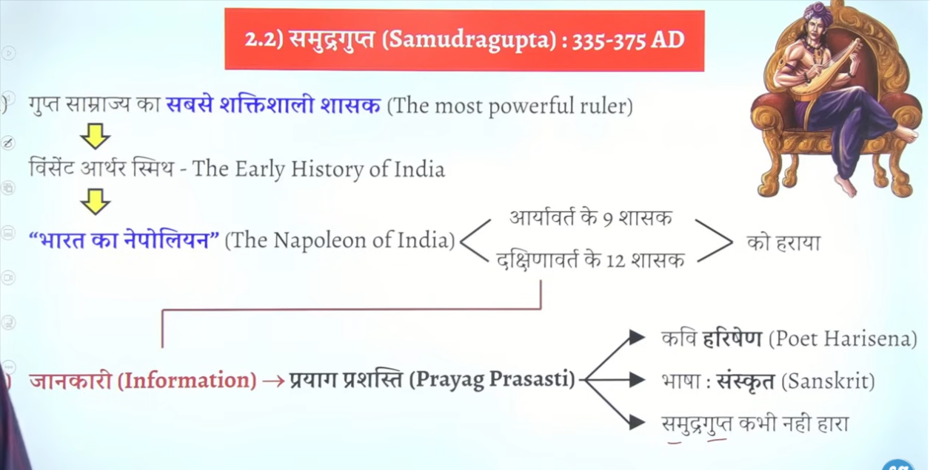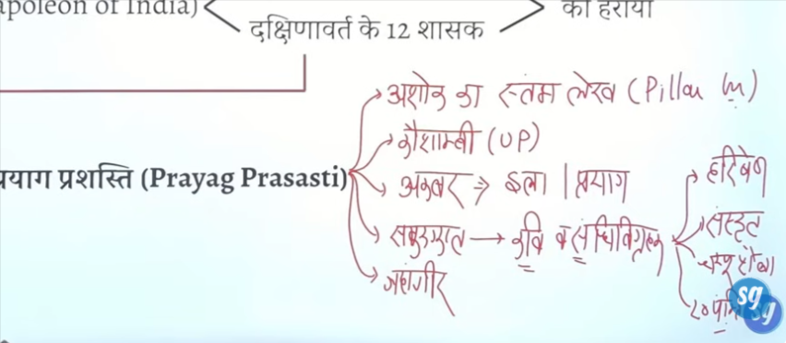

Samudragutpa ke teen title bahut he important hia
Pratham prathivi vir ka title second is parambhagvat ke upadhi , aur ahvamedhakarta ke upadhi

Do gupta shashak hue hia jinhone ashvamedh yagya kyia hai ek samduragupta and dusra kumargupta
In dono ne ashwamedh yagya ko perform kyia hai

Do bate se pata chalta ia ke inka bhagwat dharm ke patee jhukawa rahah hai
Ek to garun symbol and dusra smadurapgut ka title parmbhagwat jisse vaihnava dharm ke prate unka jhukao dekhe deta ahi

Jb uske veena bajate hue coin mile ot humen usko kaviraje ke upadhi de det usne khud se Kaviraj ka title nhai lyia tha
Prathyaam praterath = means prathvi ka Pratham veer

Uttart bharat ke 9 rjay vijayet kyai Dakshin bhart ke 12 rajyaon ko jeet lyia kuch seemant the aur kuch jungle ke 18 rajya tha
Jeet karke unke prate alag alag neete apnaee the alag alag policy apnaee the
Jaise north me complete anexxatin ke policy apnee the jikso bola jata hai prasbodharan niti

Aur south ke 12 rjaya jeet kar vapas lauta dyia aur unse boal apkeo hamre adhinata swaekary karne hoge aur tax dena haog
Aur yahe samdurhagutpa ko vishes banat ahi
Medival me hum alaudin khili and tuglaq ke bare me padenge in logo ne galte ke the jub samrjay ka vista south me kyia to delhi se direct control karne ke ksoshike the south ko it is not possible that kea pap delihi me baithdkarke southem ke state per control prapt kar lo kuki transport easy nahi tha aaj ke tarha koi train and helicopter nahi tha jo ke appa turatn puch chao mahino lagte the yatra karne me yahe unke patan ka karna bana tha
Aladuding Khilji ne yahe nahi kyai usjen direct control nahi kyai
To samduragupta bhe itna samjdhar tha ki usne dimaga lagay ke hum direct control nahi karenge direct control se vidhroh hoga to usne socha yahah ke jo raja hia unko he rjaya wapas de dyia jaye wo bas tax de det aur hamre authority accept kar le 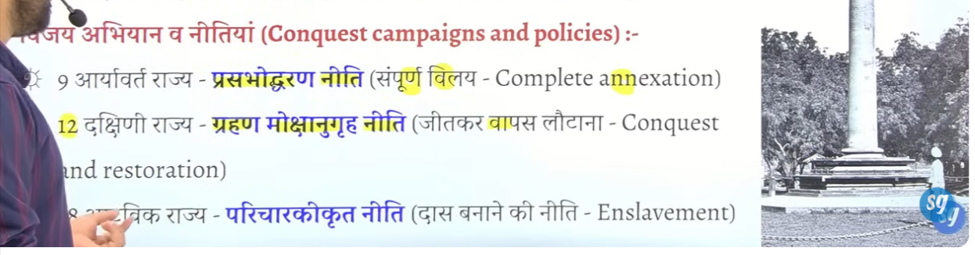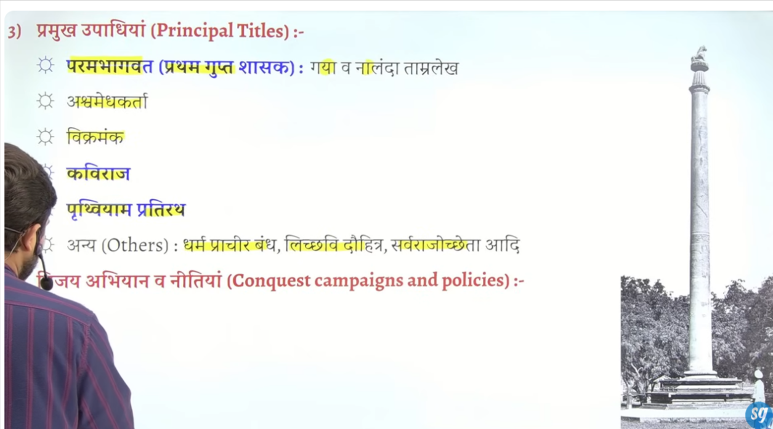

18 atveek rajyon ka bhe veelya kar lyia tha

Seemavarti rjaya the infront state the
Ye policy unhone adopt ke the

Samdurdagutpa ko Kaviraj isely bola gyaya kuuki uske sikko per usko veena bajate hue dekahaya gyaay hai

Coins
Garun coins – jisme usko sau yudhon ka veejeta kahah gaya tha
Q kiss shaahsk ko uske sikko per veena bajate hue darshaya gayay hai ? veena play karte hue depict kyia gyaya hai
Ans:Samdurgutpa

Chuke isne aswamedh yagya karwayay tha
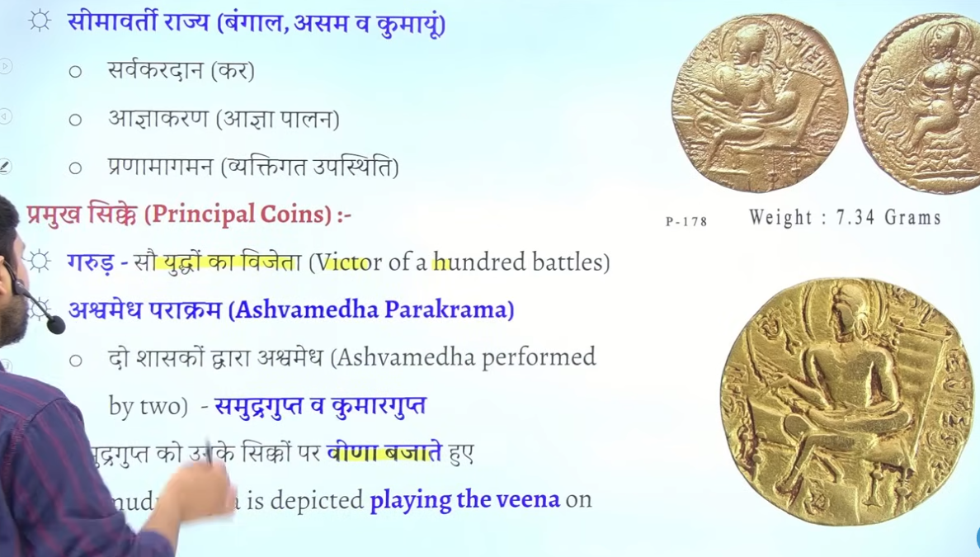

Isne garun prakar ke sikke bhe jare kyia jisme usko sau yudho ka vejeta kahah gayay hai
Aur Prayag prashashti me samdura gutpa ke bare me kahah gayay hai ki usne kabhe bhe koi yudh nahi hara tha

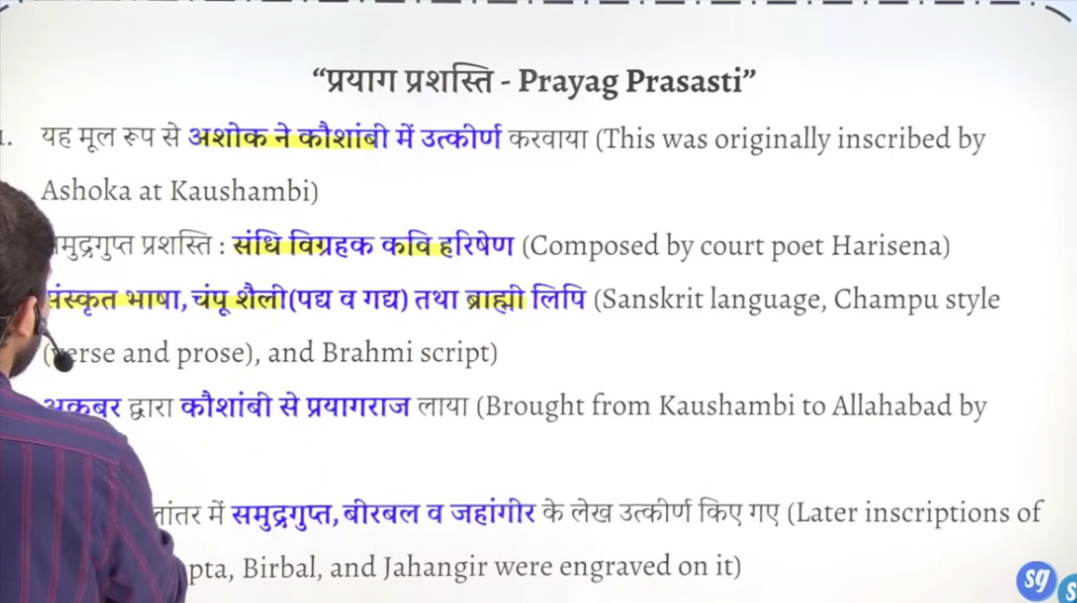

3 chandragutpa second or vikramditya

